Phase III: Software Design and Modeling
InternLink Platform
Task Delegation
Student | Project Role | Assigned Phase III Diagram | Task Focus
Izabela Lako | Team Leader + Full-Stack Developer | 3 Sequence Diagrams | Student Apply, Company Post, and University/Admin Verification with lifelines, activation bars, messages, return arrows, and Alternative success/fail sections.
Iva Hasani | Backend Developer | Component Diagram | Frontend, backend components, security, persistence, and database/data-access connections.
Deshira-Mariana Lusha | Backend Developer | Use Case Diagram | All actors and main system interactions.
Anxhela Valisi | Frontend Developer | Class Diagram | Main classes, attributes, methods, inheritance, and relationships.
Megi Shehi | Frontend Developer | State Diagrams | Opportunity Status, User Account Status, and Saved Opportunity state transitions.

1. Software Architecture

1.1 System Architecture
- Users interact with the React web frontend through role-specific dashboards.
- The frontend sends REST API requests to the Python backend.
- The backend validates authentication, role-based permissions, and input data.
- Backend components access data through the persistence layer.
- The database stores users, companies, opportunities, saved opportunities, verification statuses, and logs.
- The backend returns JSON responses to update the frontend interface.

1.2 Component Diagram - Iva Hasani
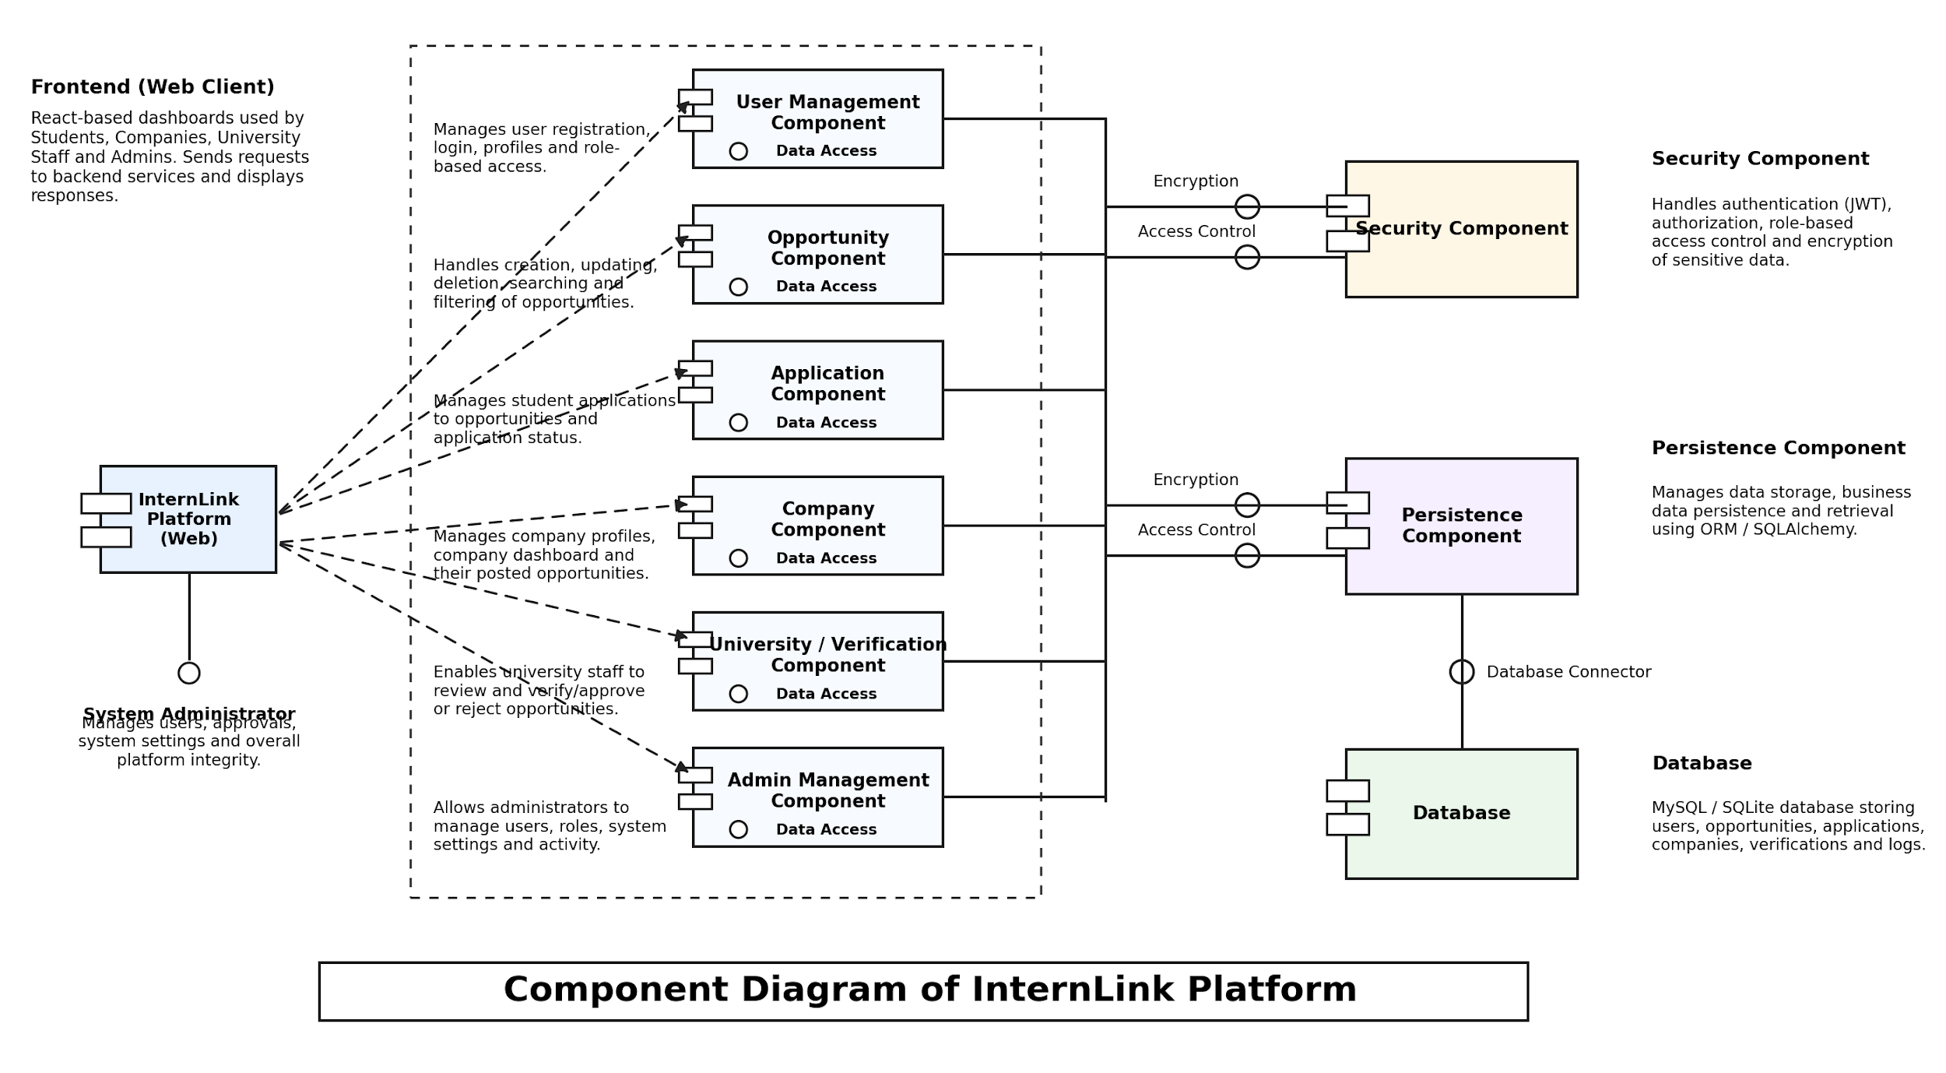

2. Detailed Design

2.1 Class Diagram - Anxhela Valisi
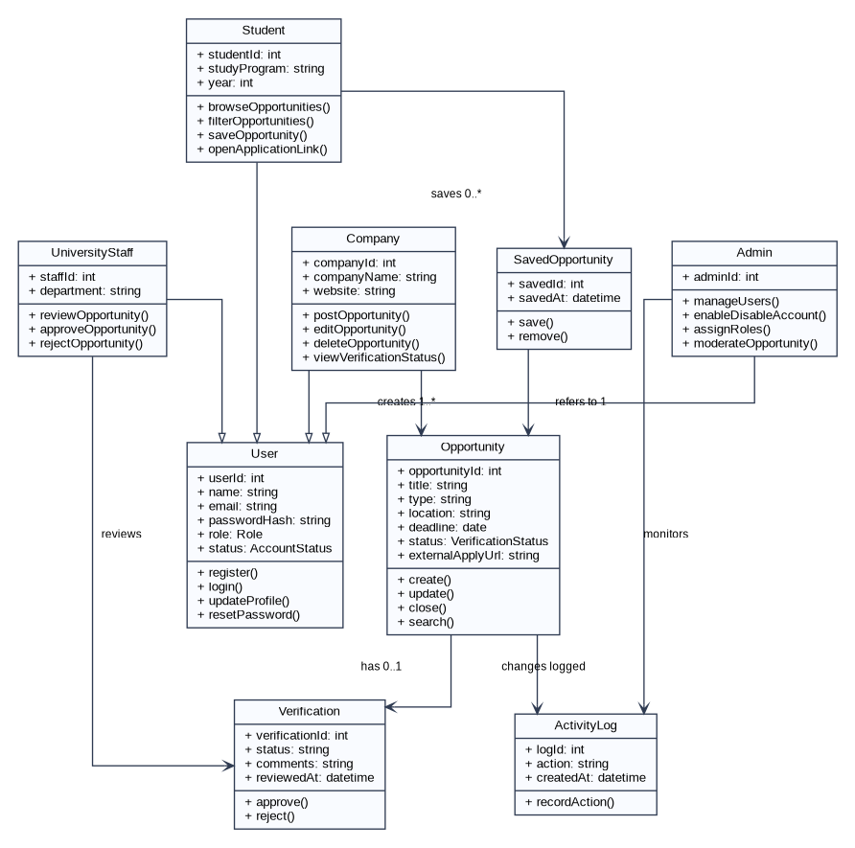

2.2 Sequence Diagrams - Izabela Lako
These diagrams are corrected to match the provided model: object lifelines, activation bars, synchronous messages, dashed return messages, and a blue Alternative frame for the success/failure path.
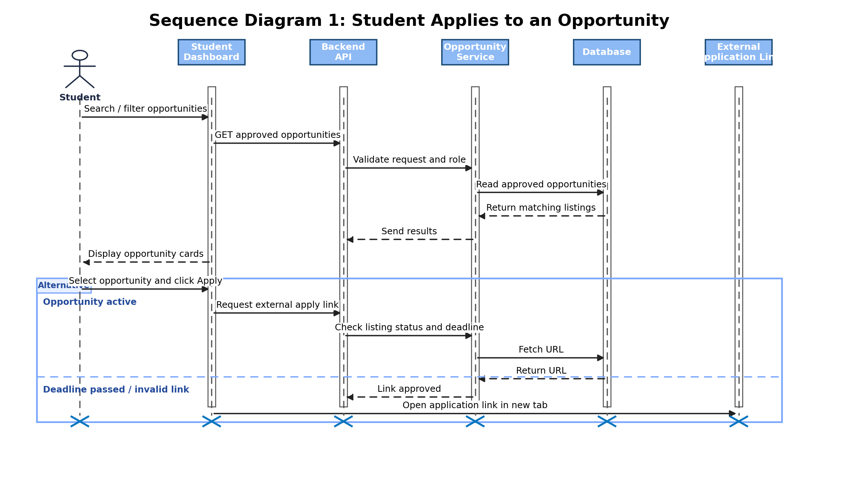

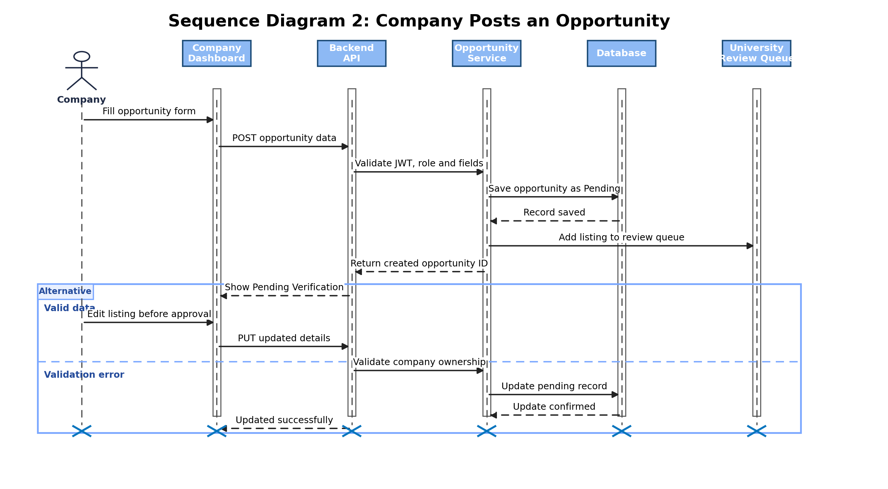

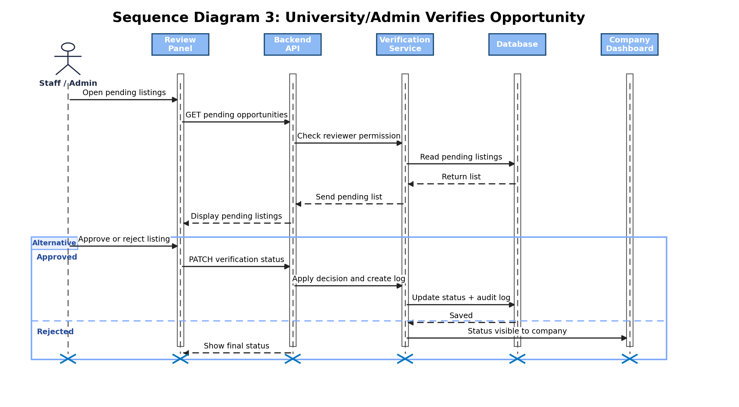

3. Modeling

3.1 Use Case Diagram - Deshira-Mariana Lusha
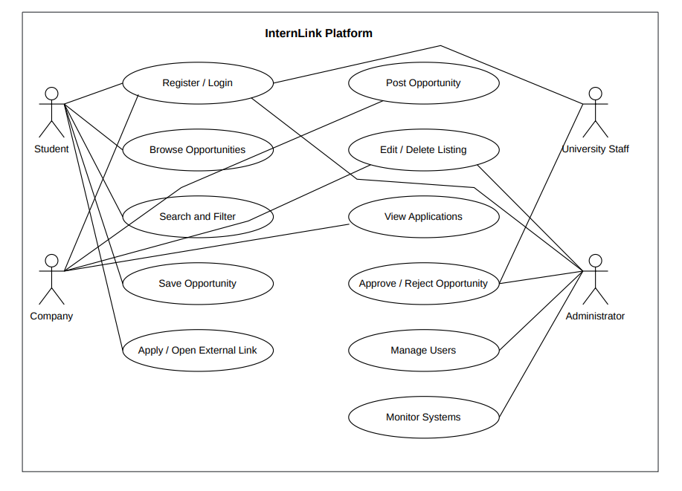

3.2 Activity Diagrams
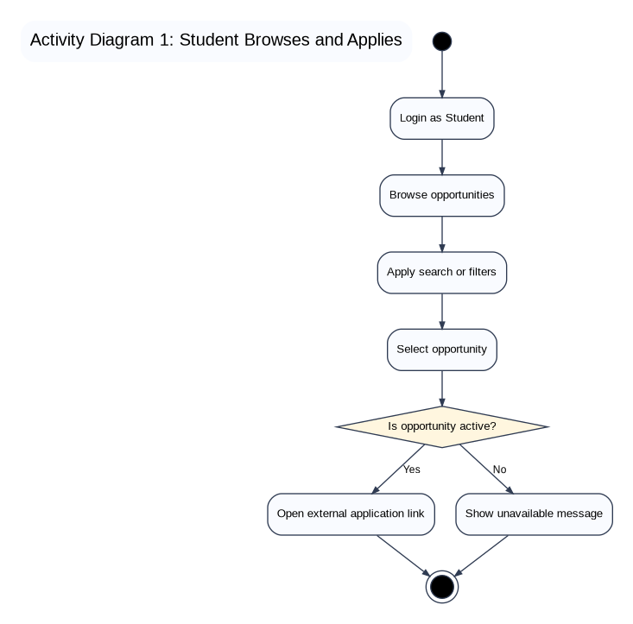
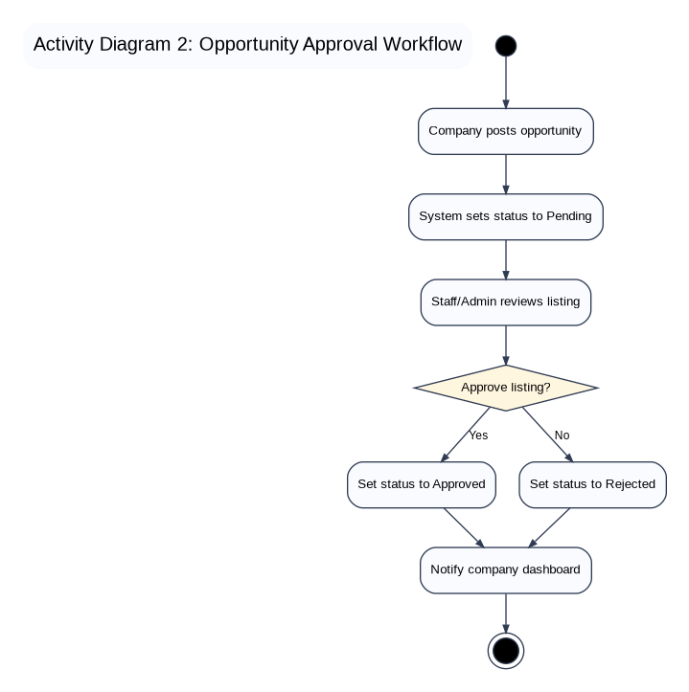

3.3 State Diagrams - Megi Shehi
The following state diagrams use the same visual logic as the sample: start node, rounded state boxes, labeled transitions, and final states. Soft colors were added for readability.
